Practical DevOps Document

Nhi Phan Nguyen Thi Yen

# Prerequisite

1. Terraform CLI
2. Azure CLI
3. Repositories:

* Micro-services application: <https://github.com/nhiphannty/sd4831_msa>
* Architecture as code: <https://github.com/nhiphannty/sd4831_azure_infrastructure>
* Jenkins Shared Library: <https://github.com/nhiphannty/devops-ci-cd>

# Setting up a CI/CD Pipeline and deploying applications on AWS EKS

## Provision infrastructure by Terraform

az login

terraform init

terraform plan

terraform apply

## Installation on virtual machine

SSH terminal from local by *az ssh vm --ip 172.171.201.238*

### Docker

Installation (<https://docs.docker.com/engine/install/ubuntu>)

for pkg in docker.io docker-doc docker-compose docker-compose-v2 podman-docker containerd runc; do sudo apt-get remove $pkg; done

sudo apt-get update

sudo apt-get install ca-certificates curl gnupg

sudo install -m 0755 -d /etc/apt/keyrings

curl -fsSL https://download.docker.com/linux/ubuntu/gpg | sudo gpg --dearmor -o /etc/apt/keyrings/docker.gpg

sudo chmod a+r /etc/apt/keyrings/docker.gpg

echo \

"deb [arch=$(dpkg --print-architecture) signed-by=/etc/apt/keyrings/docker.gpg] https://download.docker.com/linux/ubuntu \

$(. /etc/os-release && echo "$VERSION_CODENAME") stable" | \

sudo tee /etc/apt/sources.list.d/docker.list > /dev/null

sudo apt-get update

sudo apt-get install docker-ce docker-ce-cli containerd.io docker-buildx-plugin docker-compose-plugin

Post installation (<https://docs.docker.com/engine/install/linux-postinstall/>)

sudo usermod -aG docker $USER

Log out then log back in

newgrp docker

docker run hello-world

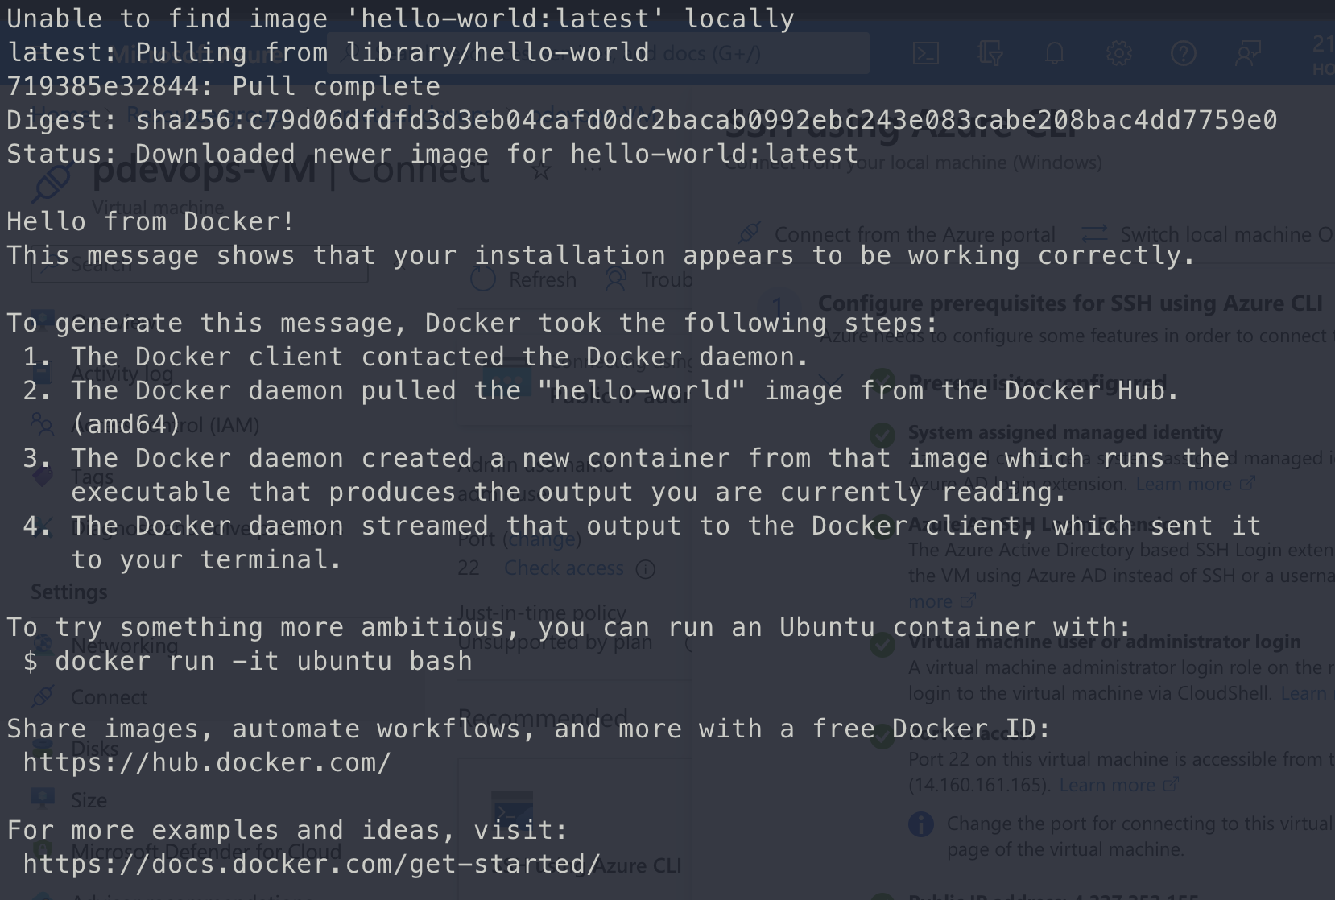

### Jenkins server

(<https://kubernetes.io/docs/tasks/tools/install-kubectl-linux/>)

curl -LO "https://dl.k8s.io/release/**$(**curl -L -s https://dl.k8s.io/release/stable.txt**)**/bin/linux/amd64/kubectl"

curl -LO "https://dl.k8s.io/release/**$(**curl -L -s https://dl.k8s.io/release/stable.txt**)**/bin/linux/amd64/kubectl.sha256"

echo "**$(**cat kubectl.sha256**)** kubectl" | sha256sum --check

sudo install -o root -g root -m 0755 kubectl /usr/local/bin/kubectl

kubectl version

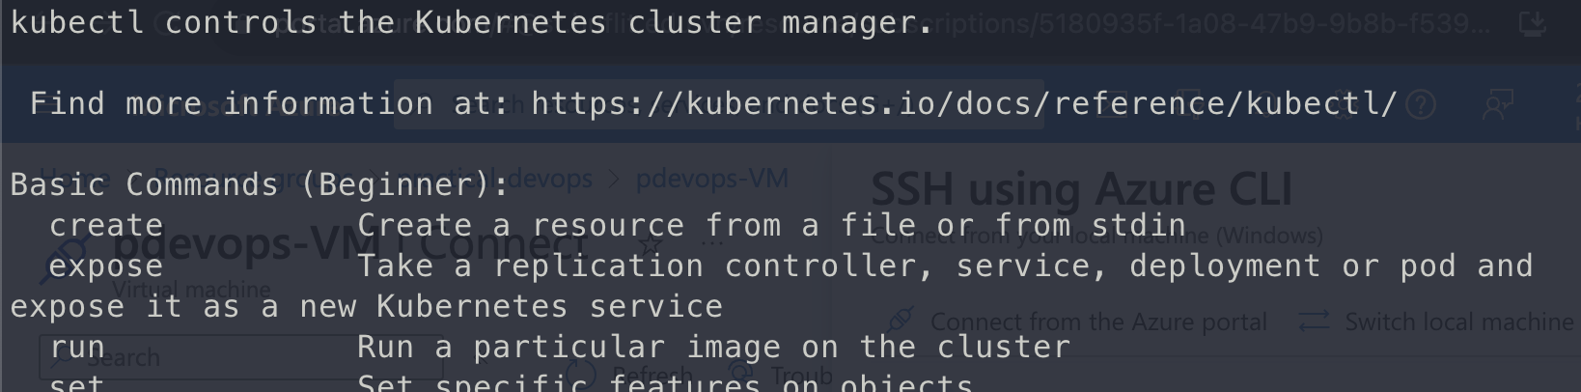

(<https://www.jenkins.io/doc/book/installing/linux/#installation-of-java>)

sudo apt update

sudo apt install fontconfig openjdk-17-jre

java -version

openjdk version "17.0.8" 2023-07-18

OpenJDK Runtime Environment **(**build 17.0.8+7-Debian-1deb12u1**)**

OpenJDK 64-Bit Server VM **(**build 17.0.8+7-Debian-1deb12u1, mixed mode, sharing**)**

(<https://www.jenkins.io/doc/book/installing/linux/#long-term-support-release>)

sudo wget -O /usr/share/keyrings/jenkins-keyring.asc \

https://pkg.jenkins.io/debian-stable/jenkins.io-2023.key

echo deb **[**signed-by**=**/usr/share/keyrings/jenkins-keyring.asc] \

https://pkg.jenkins.io/debian-stable binary/ | sudo tee \

/etc/apt/sources.list.d/jenkins.list **>** /dev/null

sudo apt-get update

sudo apt-get install jenkins

Start Jenkins (<https://www.jenkins.io/doc/book/installing/linux/#start-jenkins>)

sudo systemctl start jenkins

Run:

sudo usermod -a -G docker Jenkins

newgrp docker

## Set up Jenkins pipeline for CI/CD

Go to Jenkins: http://VM IP:8080

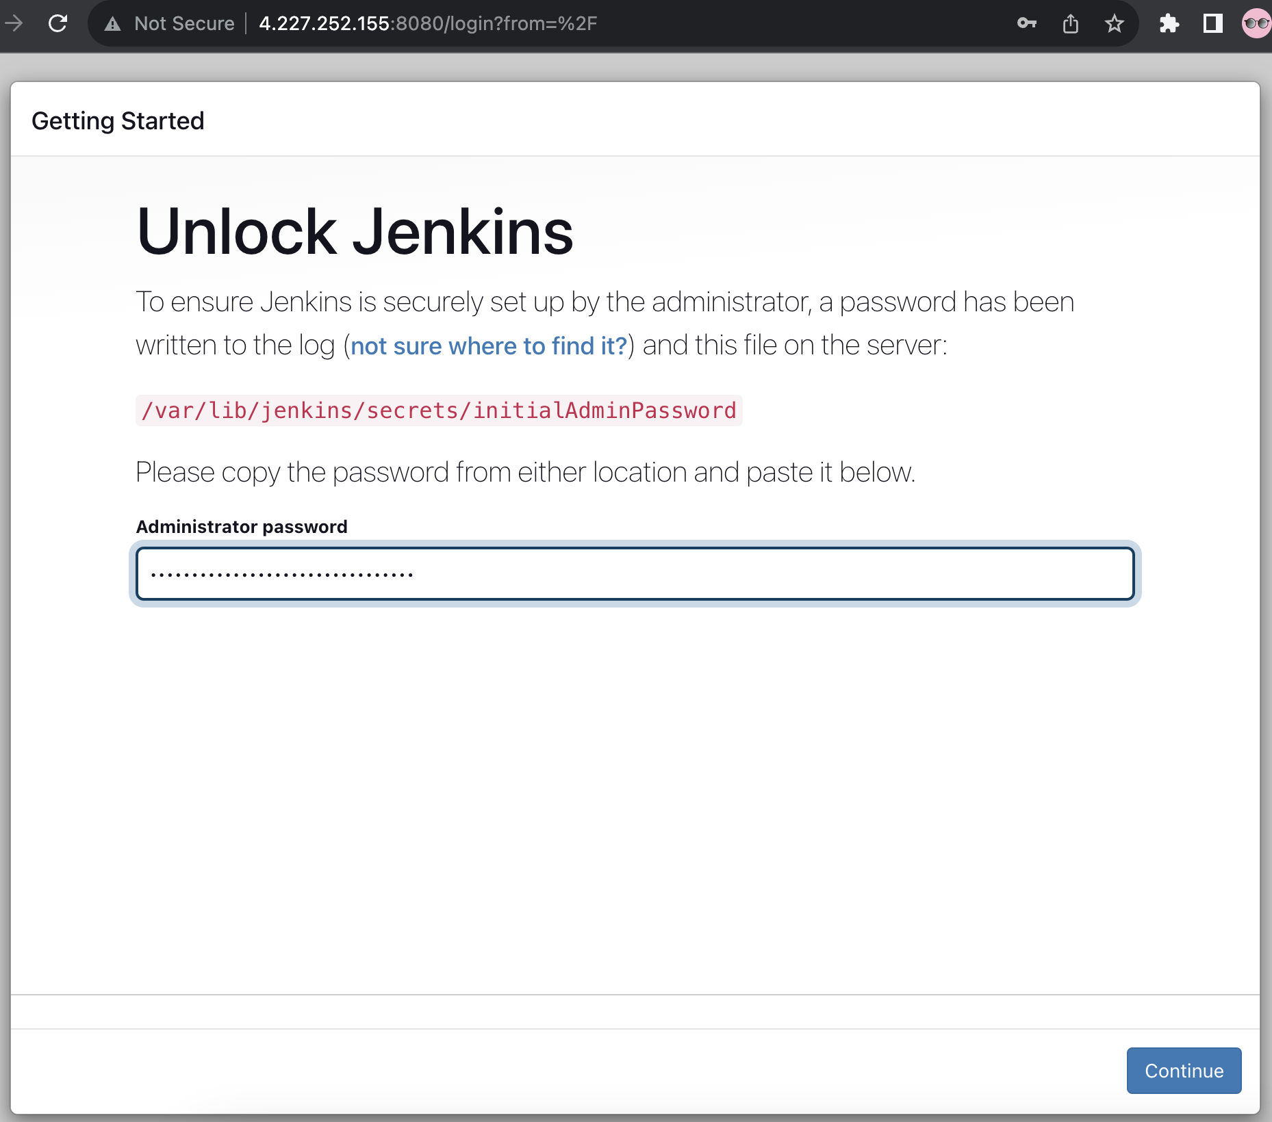

Get initial admin password

sudo cat /var/lib/jenkins/secrets/initialAdminPassword



Install Jenkins suggested plugins

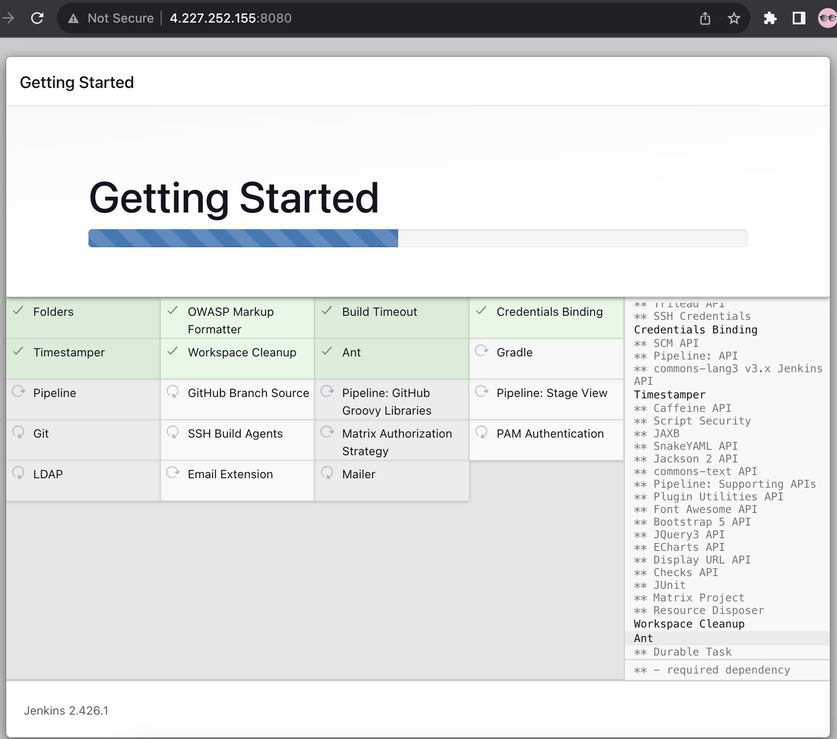

Skip create admin account

Start using Jenkins

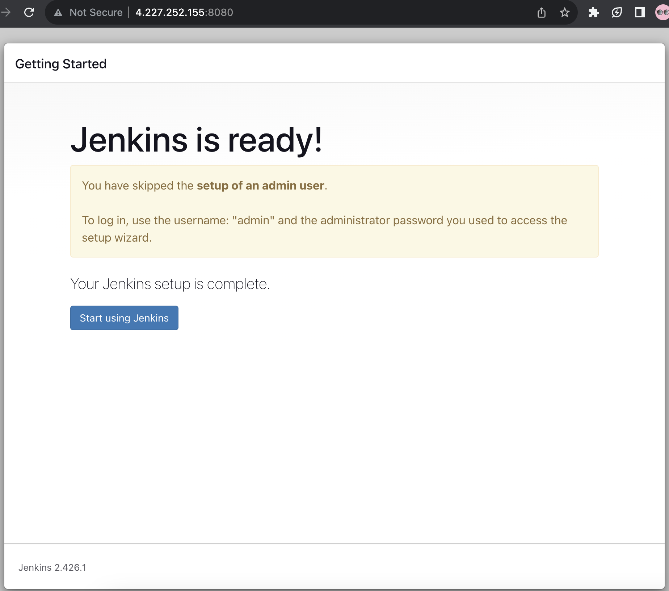

Go to Manage Jenkins 🡪 Plugins

Install plugins

* [Docker Pipeline](https://plugins.jenkins.io/docker-workflow)
* [Kubernetes](https://plugins.jenkins.io/kubernetes)
* [Pipeline Utility Steps](https://plugins.jenkins.io/pipeline-utility-steps)

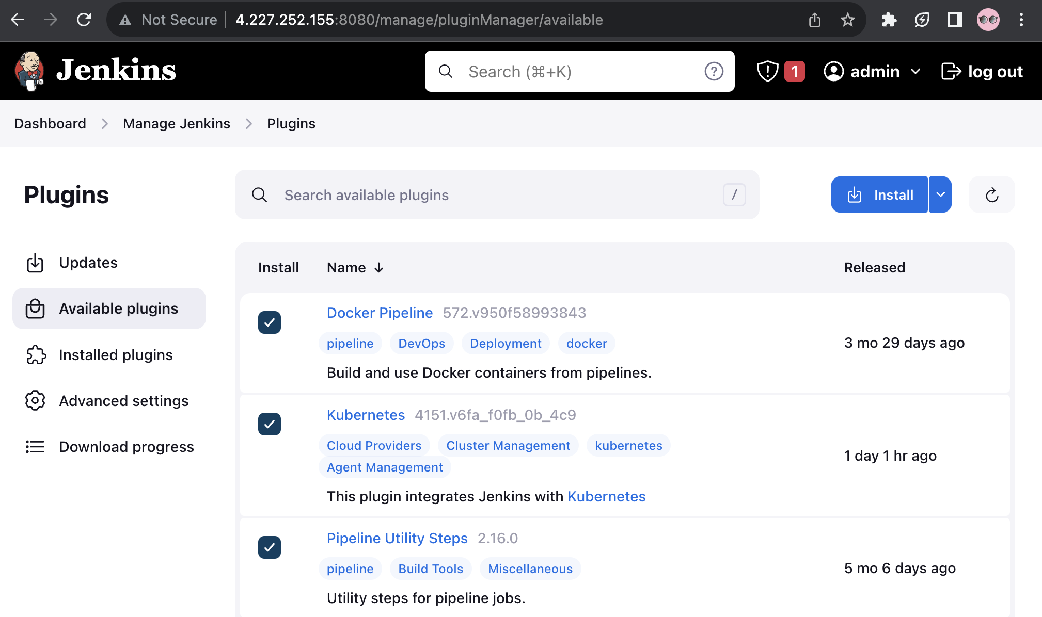

Check “Restart Jenkins…”

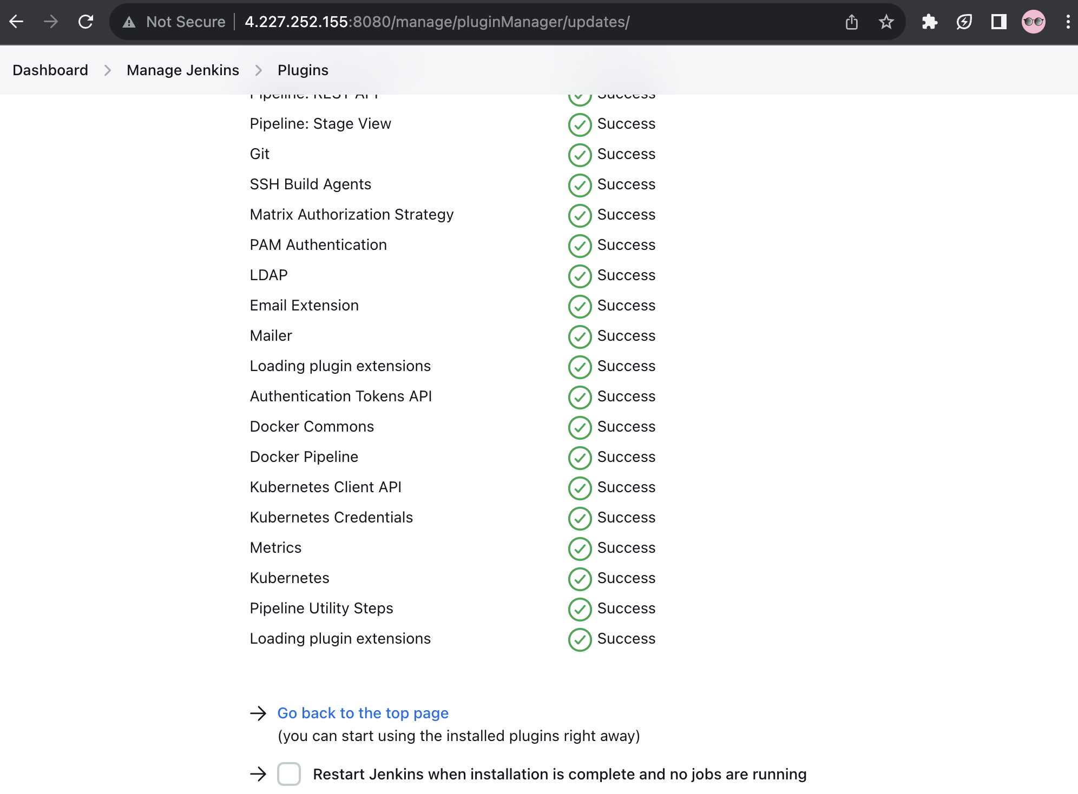

Refresh and log in with Username and Password: admin/[initial password]

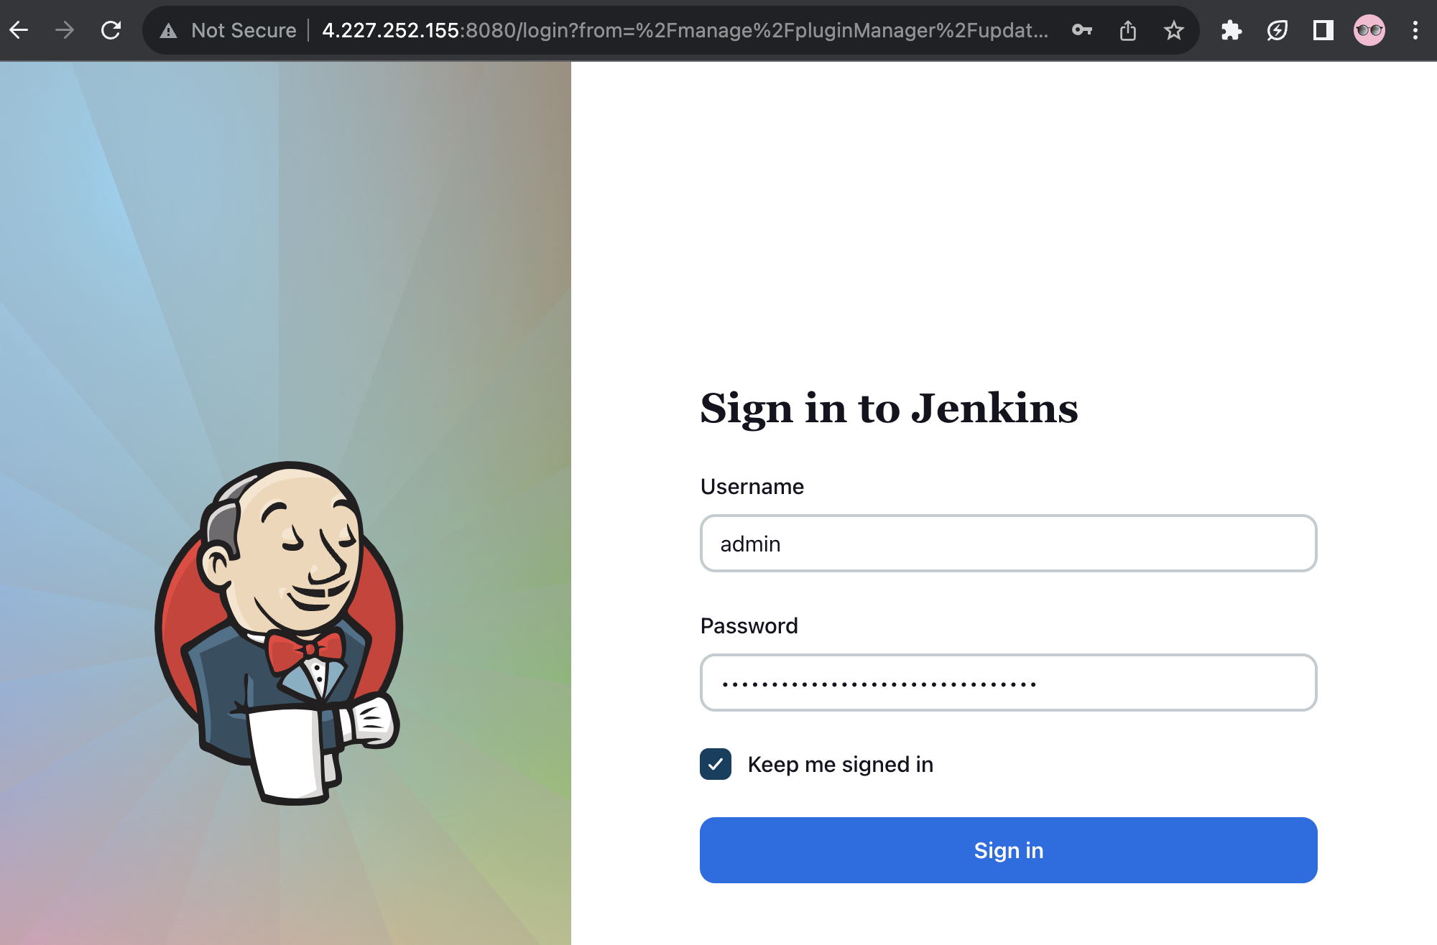

Manage Jenkins 🡪 Security > Credentials 🡪 System 🡪 Global credentials (unrestricted)

* GitHub with Kind Username with password is access token (ID name: github)
* ACR with Kind Username with password (ID name: acr-token)

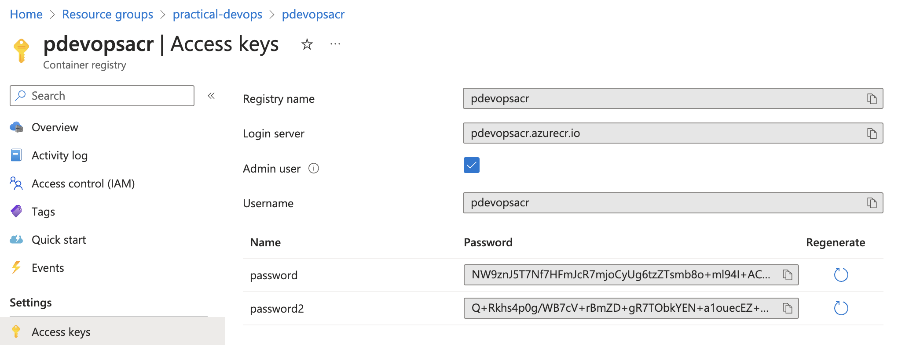

* kubeconfig with Kind Secret file (ID name: aks)

Get kubectl config file: az aks get-credentials -g practical-devops -n pdevops-aks

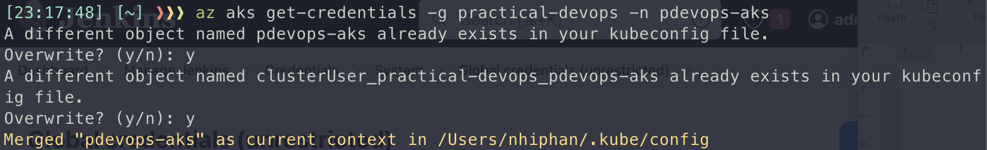

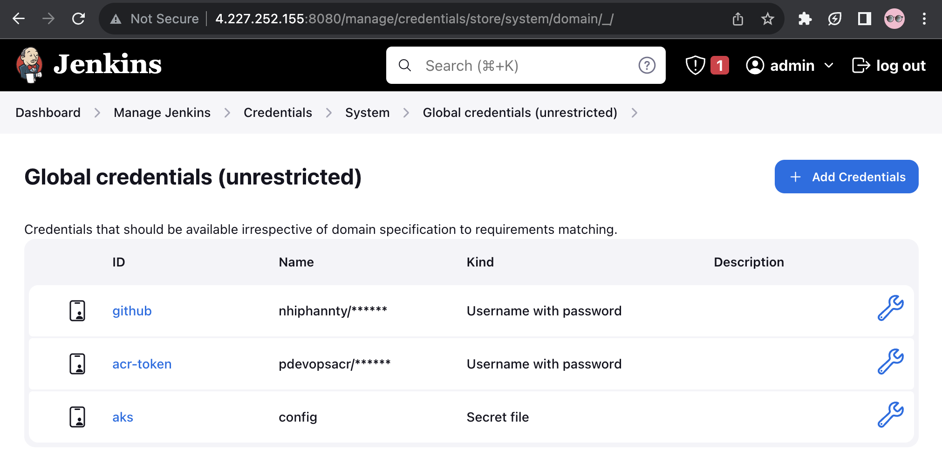

Manage Jenkins 🡪 System

* GitHub Enterprise Servers
  + API endpoint: <https://api.github.com>
  + Name: devops

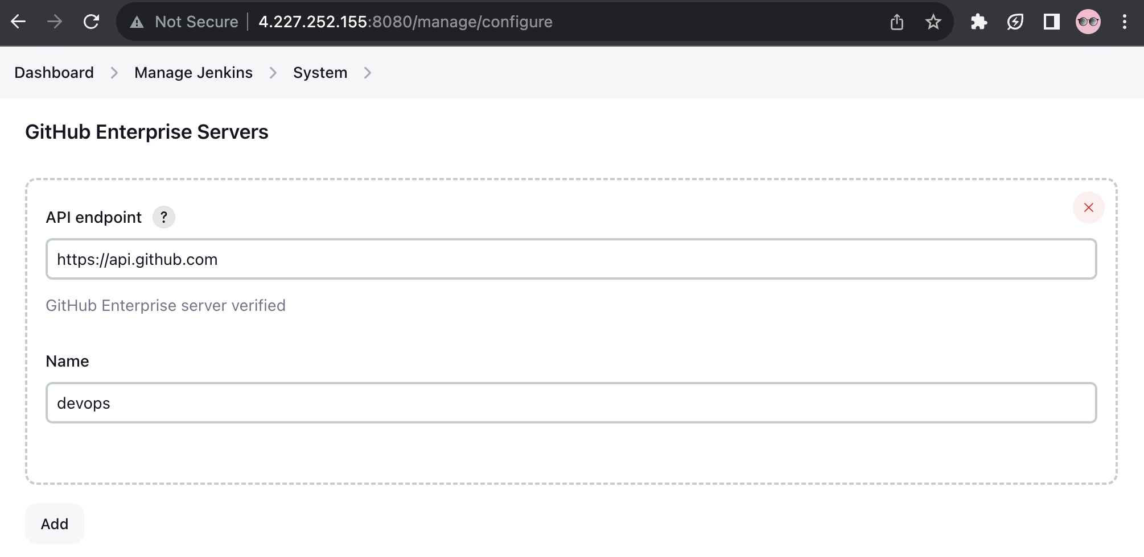

* Global Pipeline Libraries
  + Name: devops-jenkins-ci
  + Default version: main
  + Allow default version to be overridden
  + Include @Library changes in job recent changes
  + Retrieval method: Modern SCM
    - Source Code Management: Git
    - Project Repository: <https://github.com/nhiphannty/devops-ci-cd>
    - Credentials: github

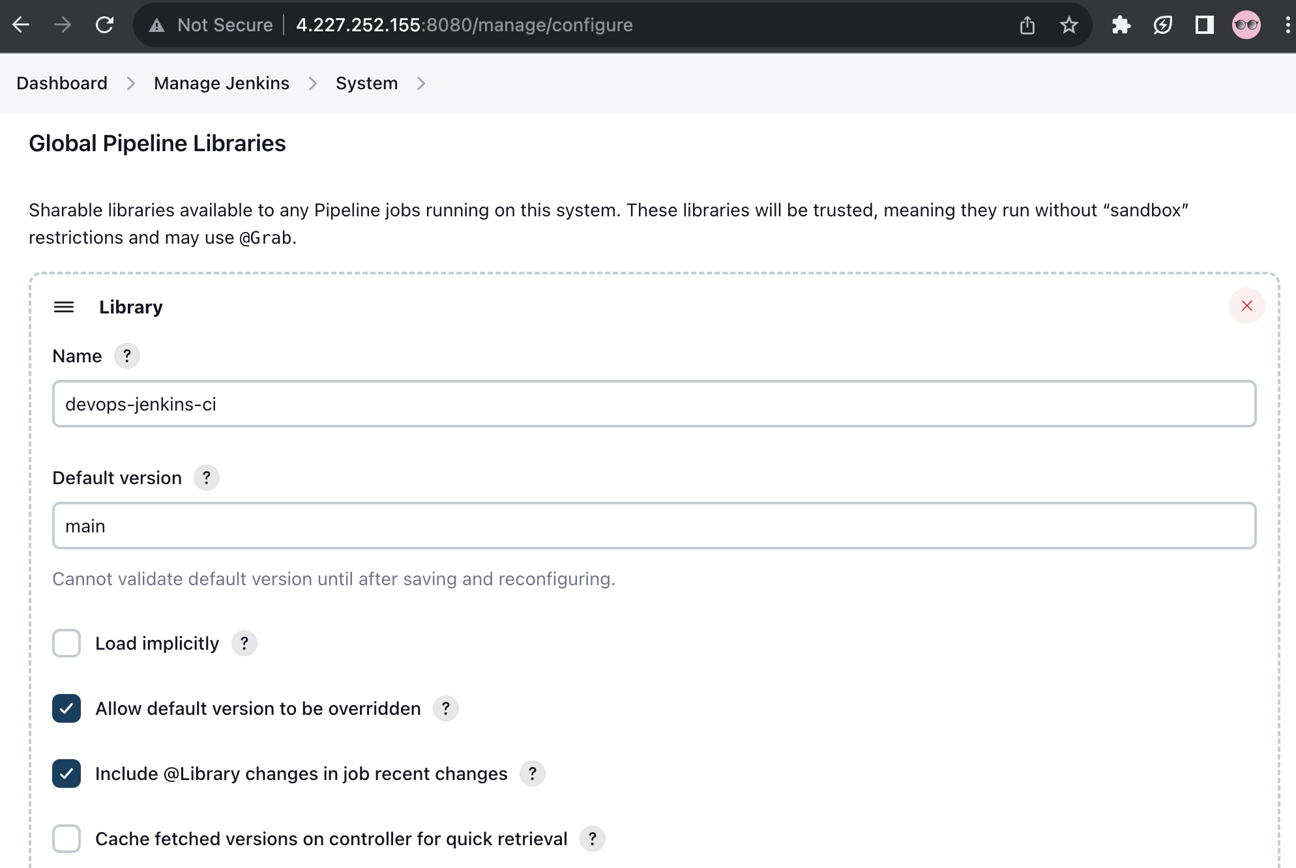

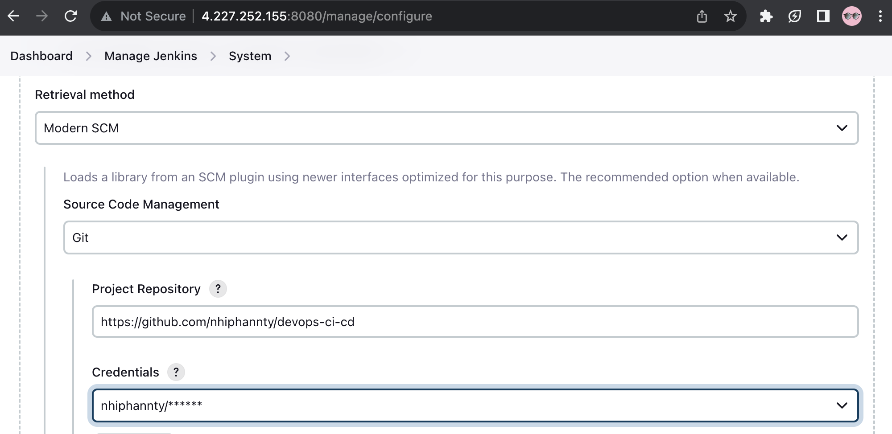

New item - backend:

* Pipeline
* Name: backend
* GitHub project: <https://github.com/nhiphannty/sd4831_msa>
* Pipeline
  + Pipeline script from SCM
  + Git
  + <https://github.com/nhiphannty/sd4831_msa>
  + github
  + main
  + ./src/backend/Jenkinsfile

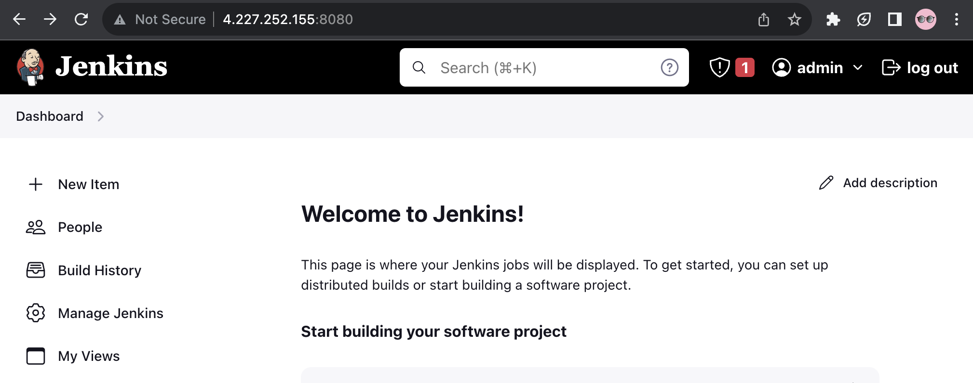

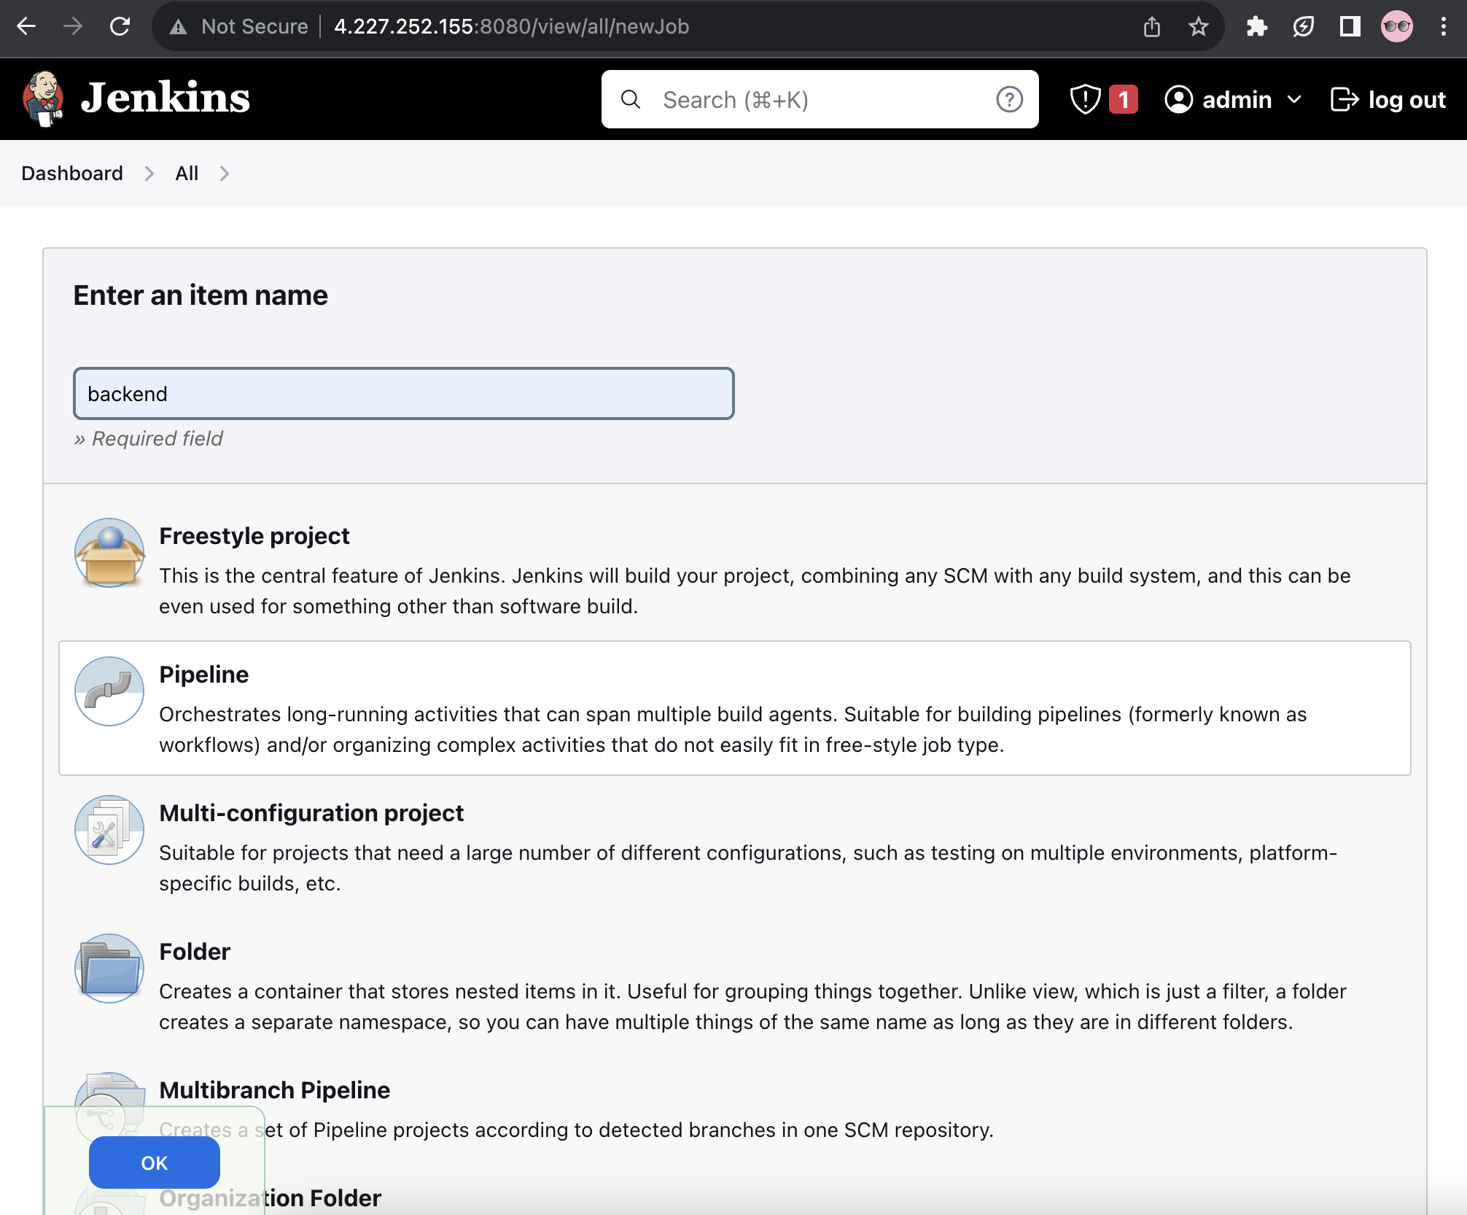

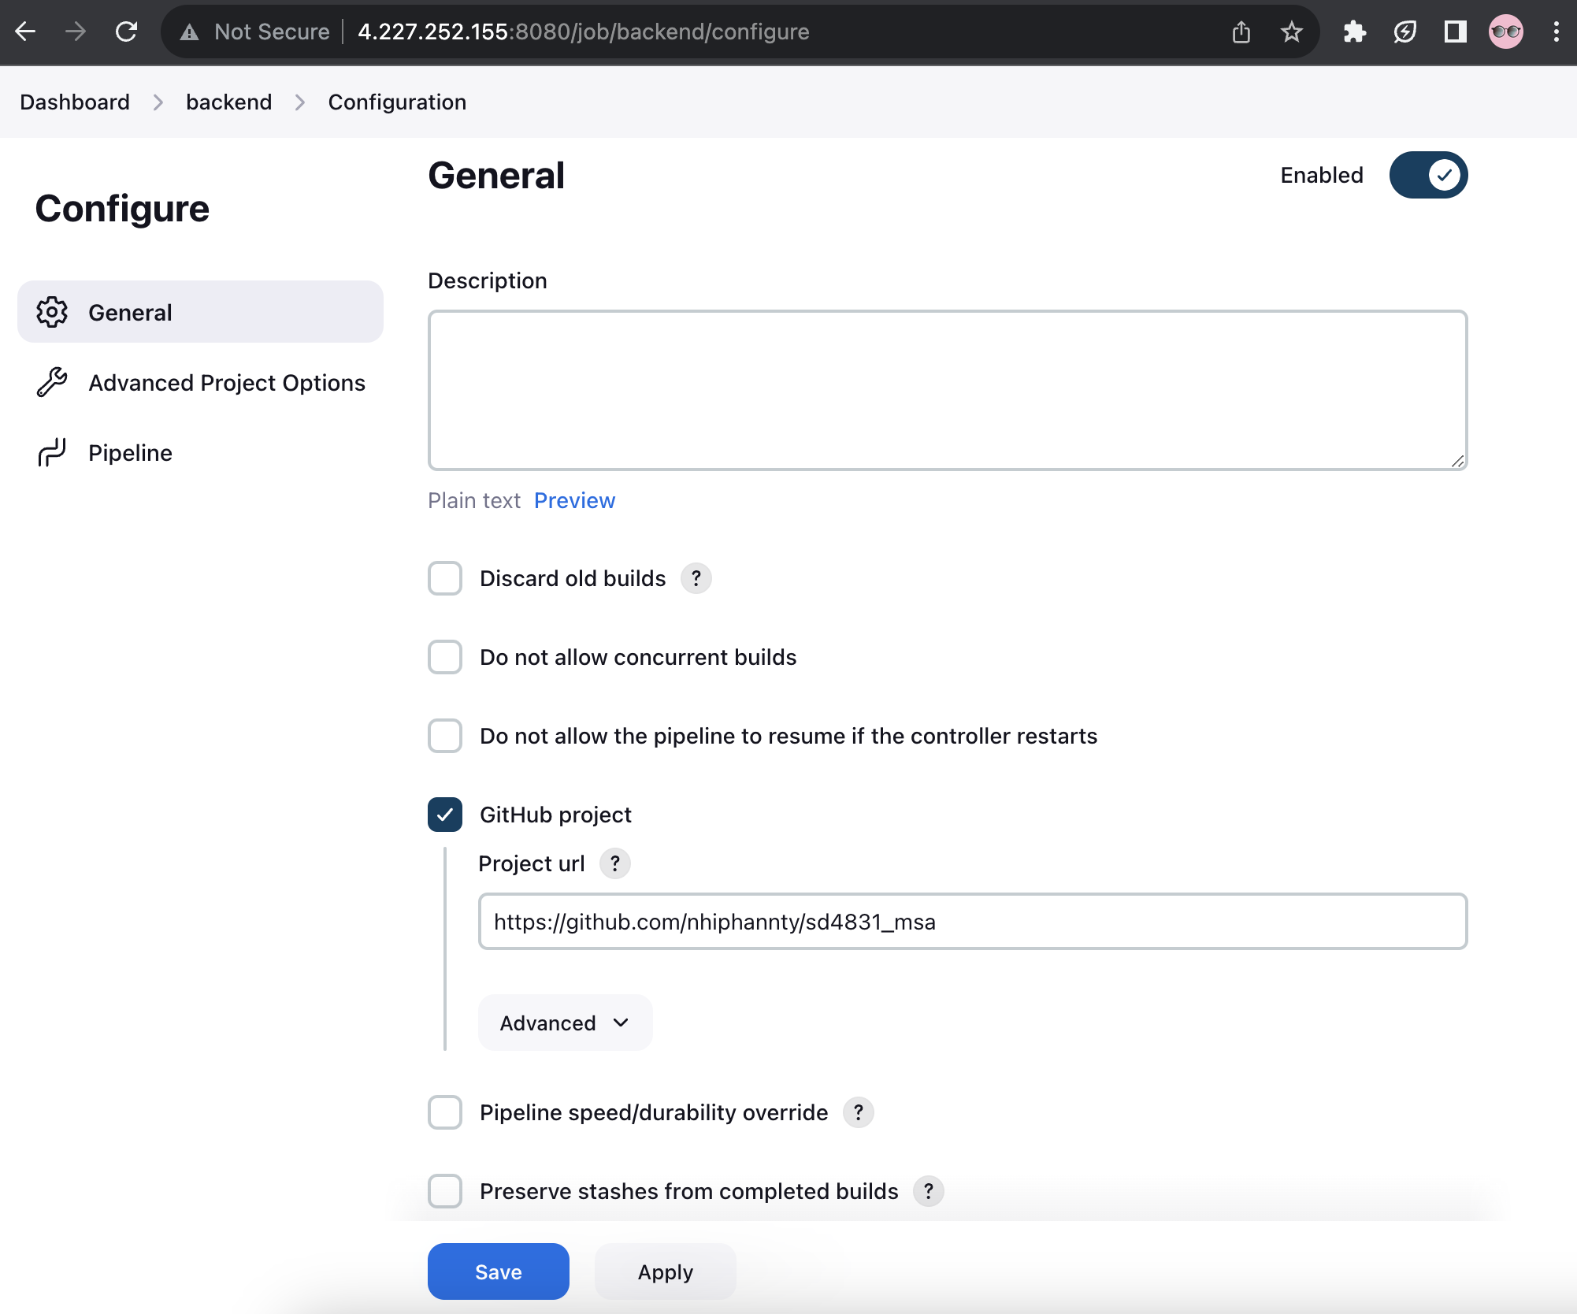

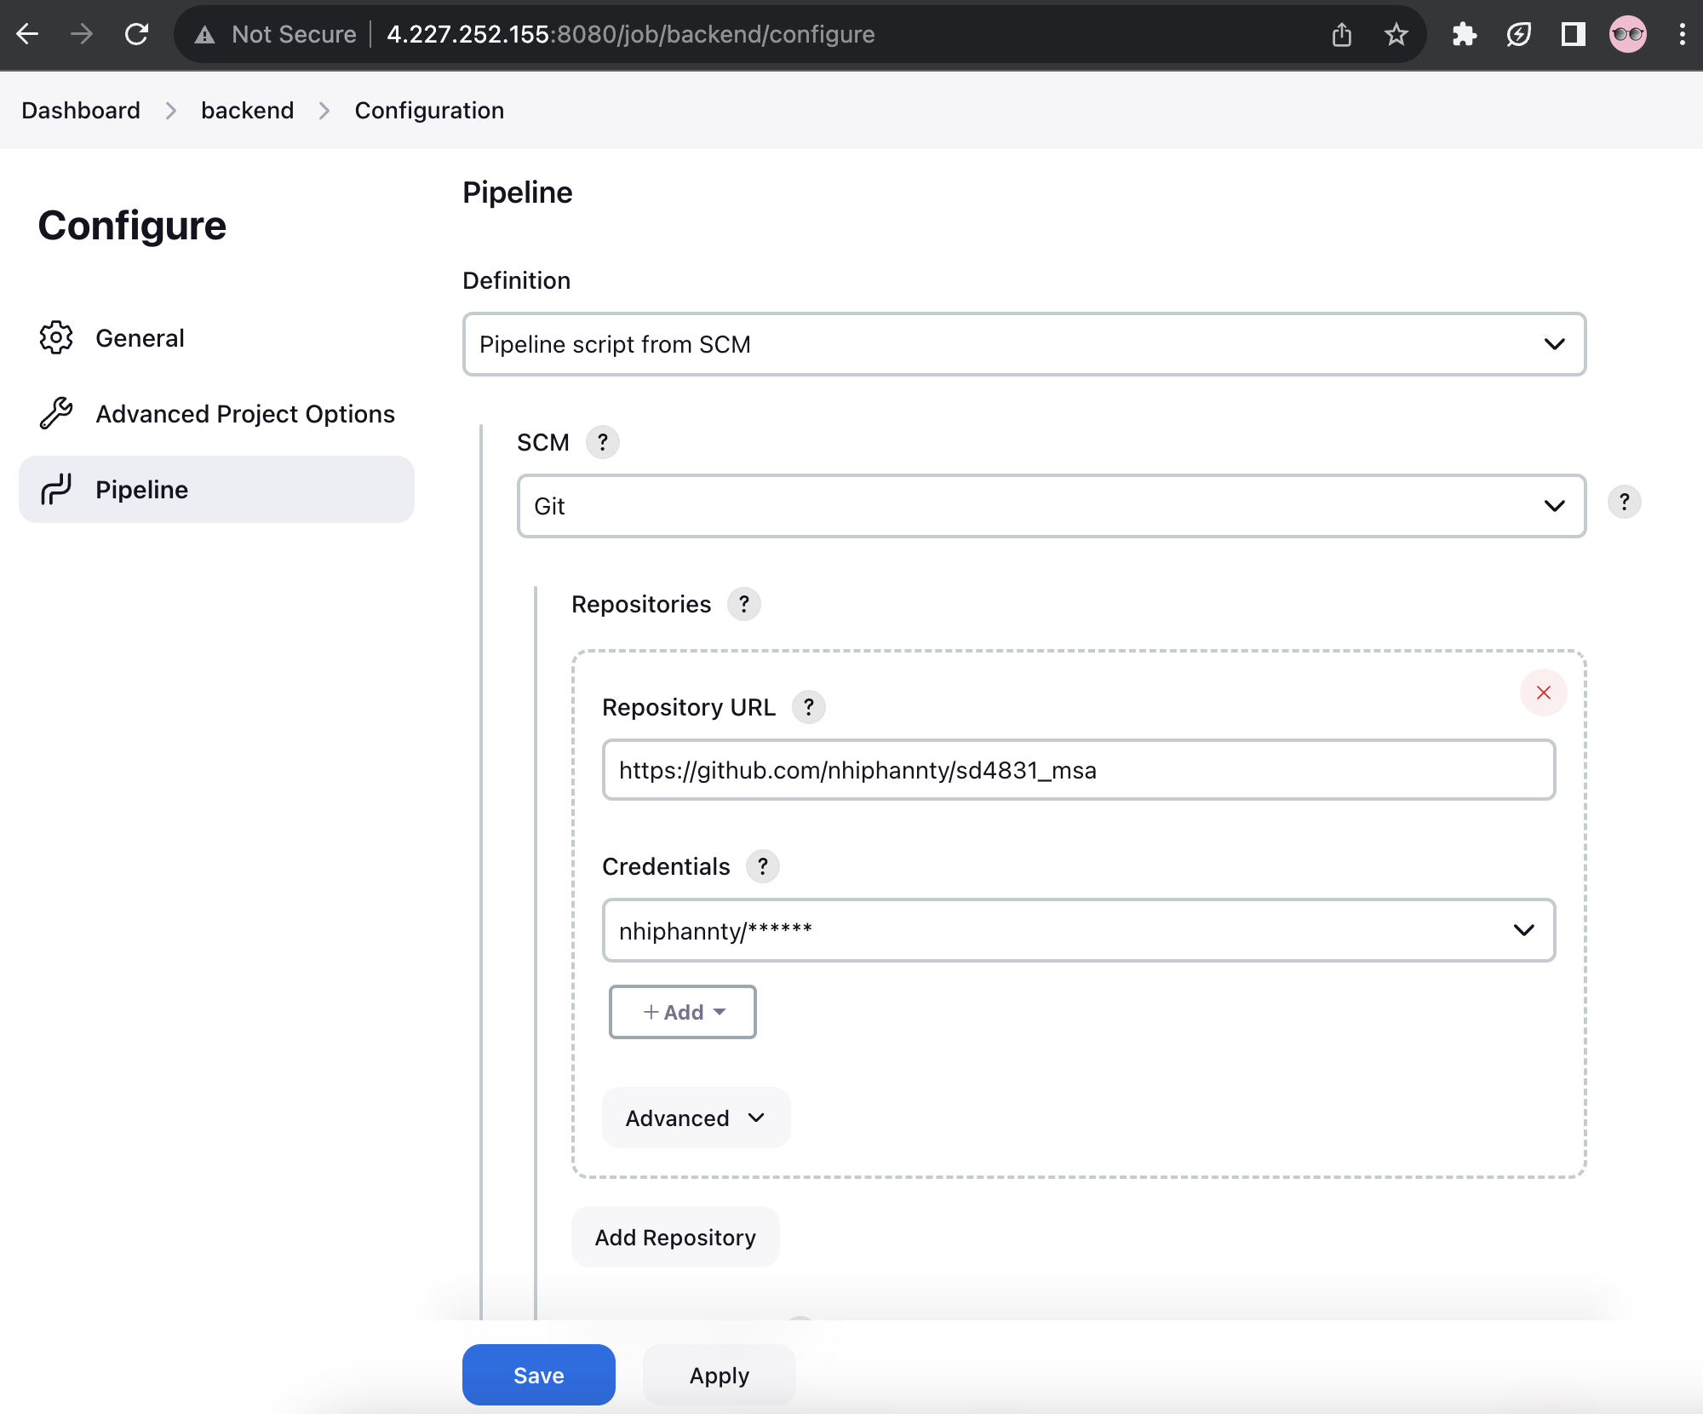

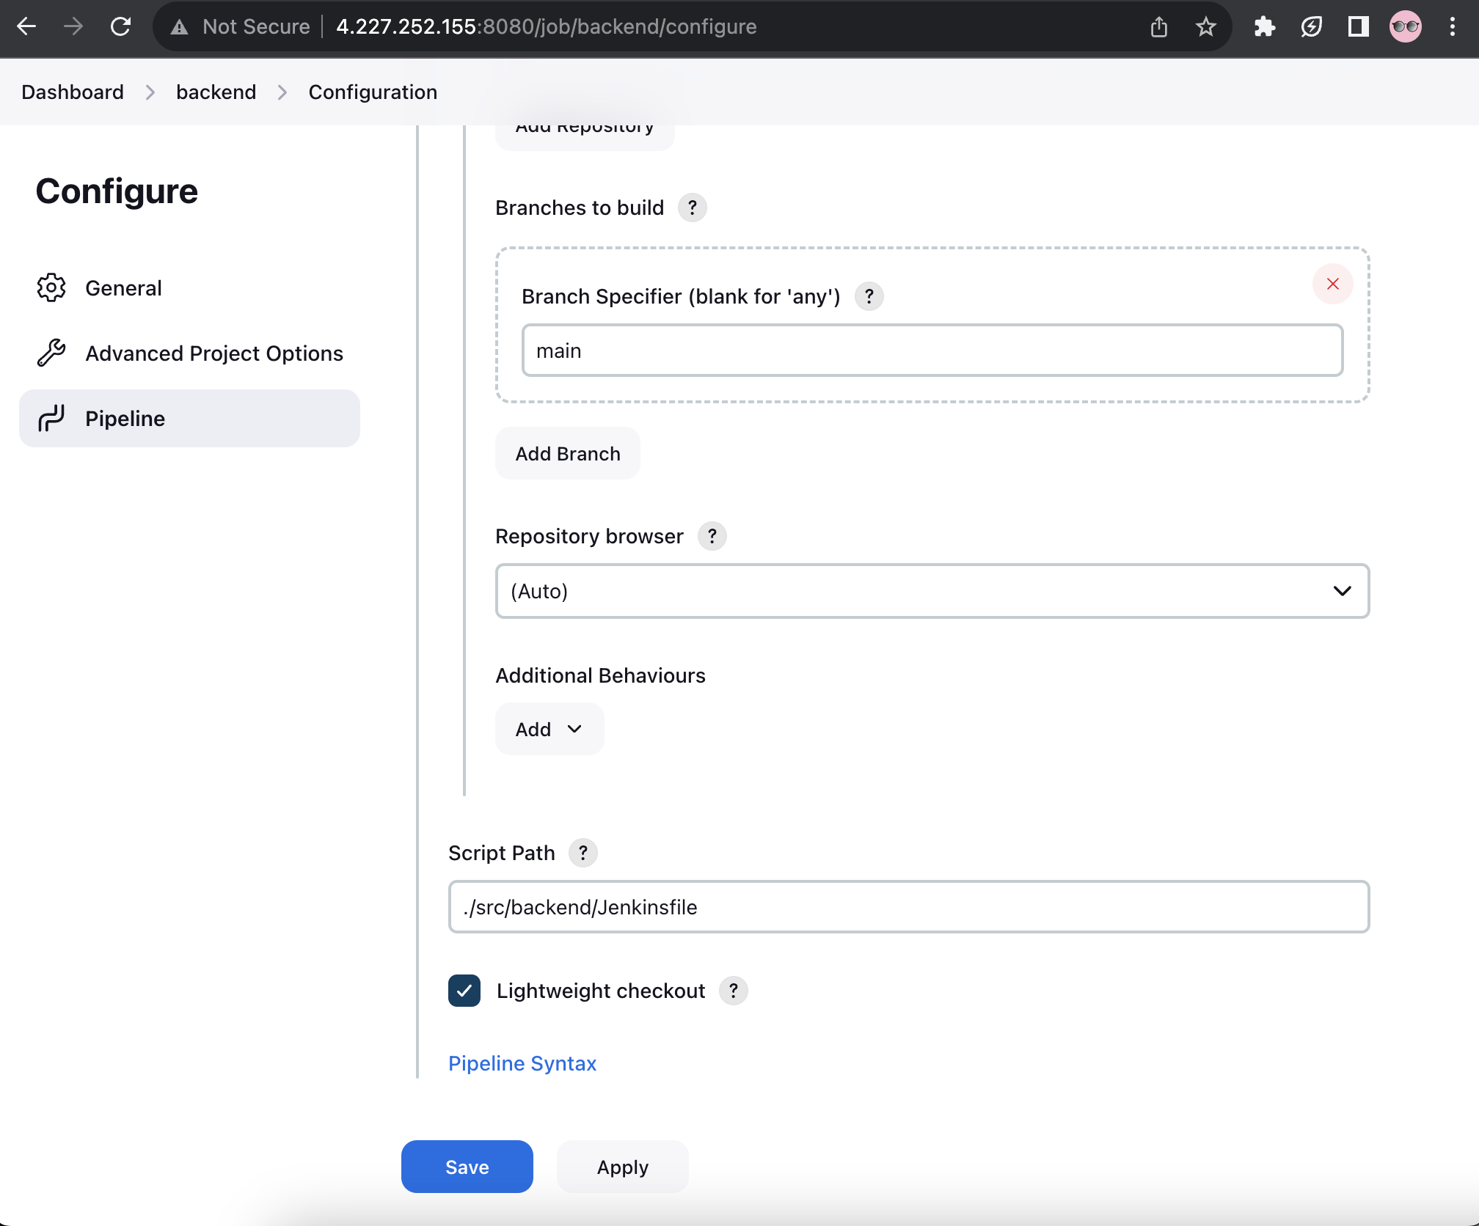

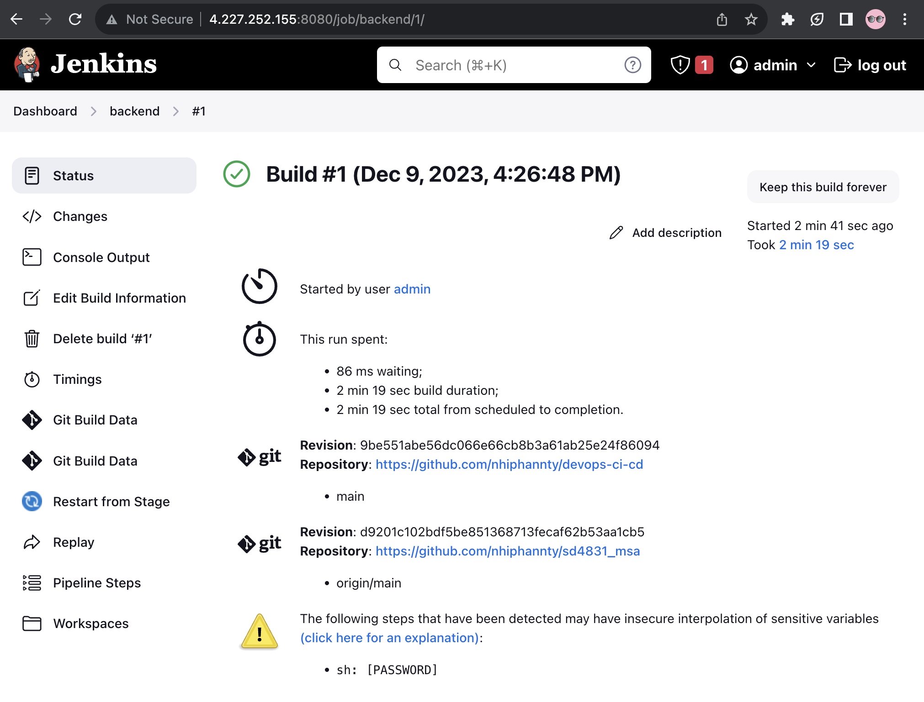

New item - frontend:

* Pipeline
* Name: frontend
* GitHub project: <https://github.com/nhiphannty/sd4831_msa>
* Pipeline
  + Pipeline script from SCM
  + Git
  + <https://github.com/nhiphannty/sd4831_msa>
  + github
  + main
  + ./src/frontend/Jenkinsfile

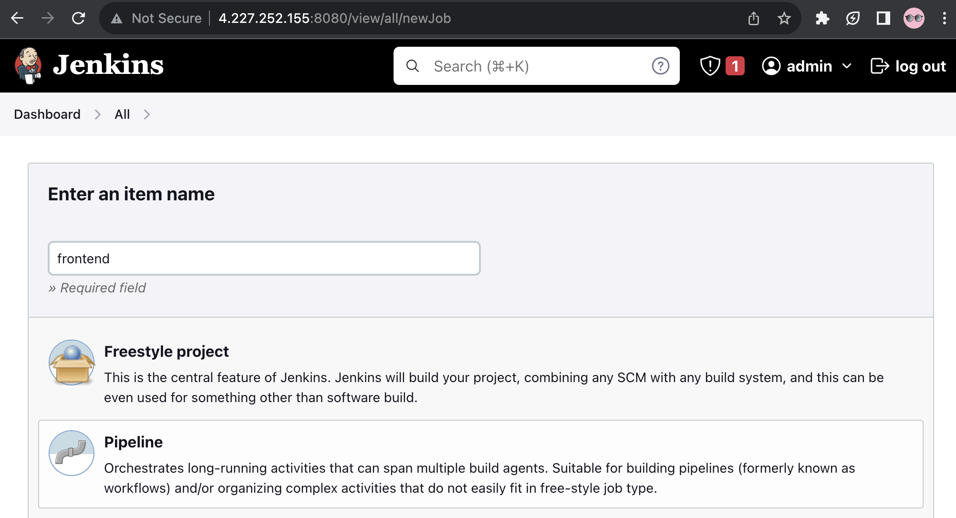

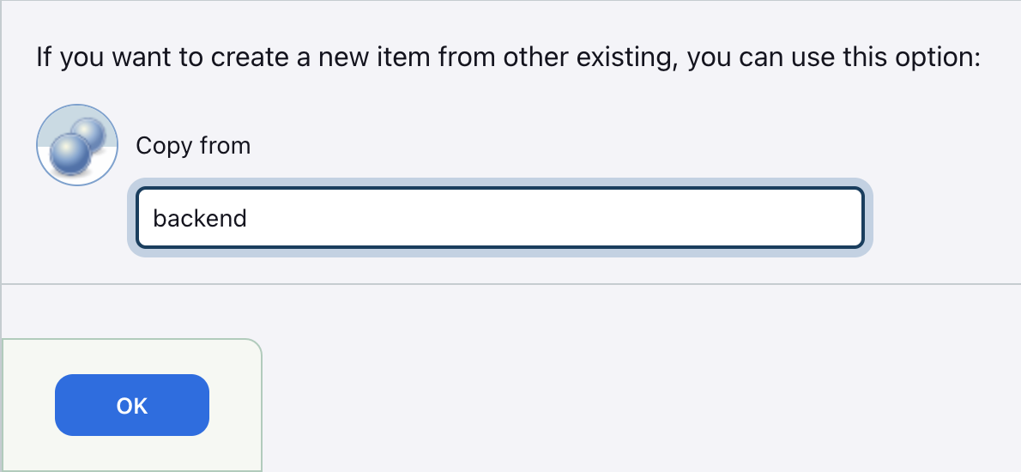

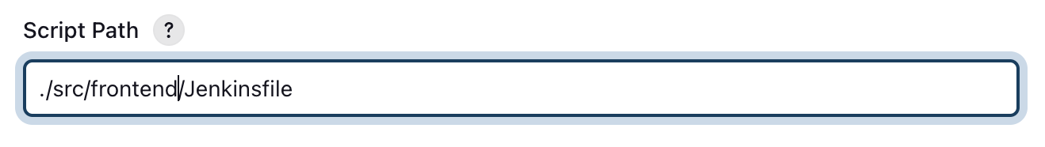

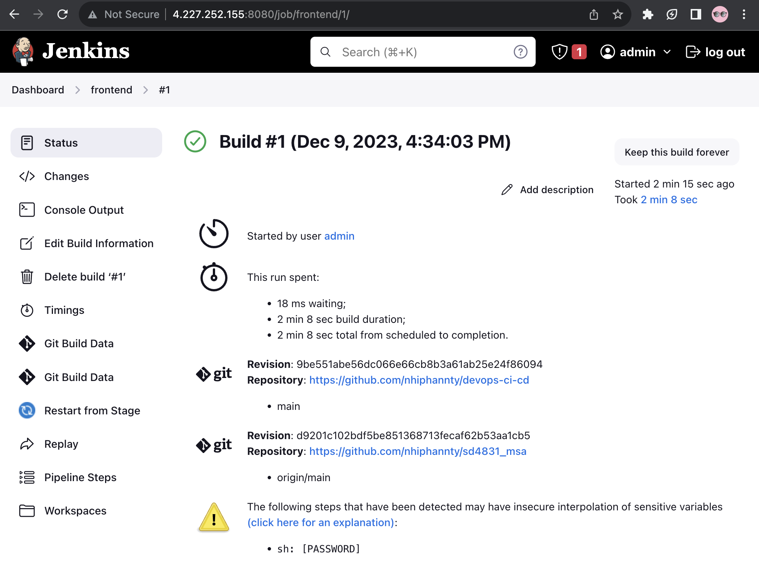

# Reuse Jenkins CI and use GitOps for the CD pipeline.

## Install Argo CD

([https://argo-cd.readthedocs.io/en/stable/getting_started](https://argo-cd.readthedocs.io/en/stable/getting_started/))

kubectl create namespace argocd

kubectl apply -n argocd -f https://raw.githubusercontent.com/argoproj/argo-cd/stable/manifests/install.yaml

kubectl patch svc argocd-server -n argocd -p '{"spec": {"type": "LoadBalancer"}}'

kubectl port-forward svc/argocd-server -n argocd 8080:443

Go to AKS and go to IP address at argocd-server

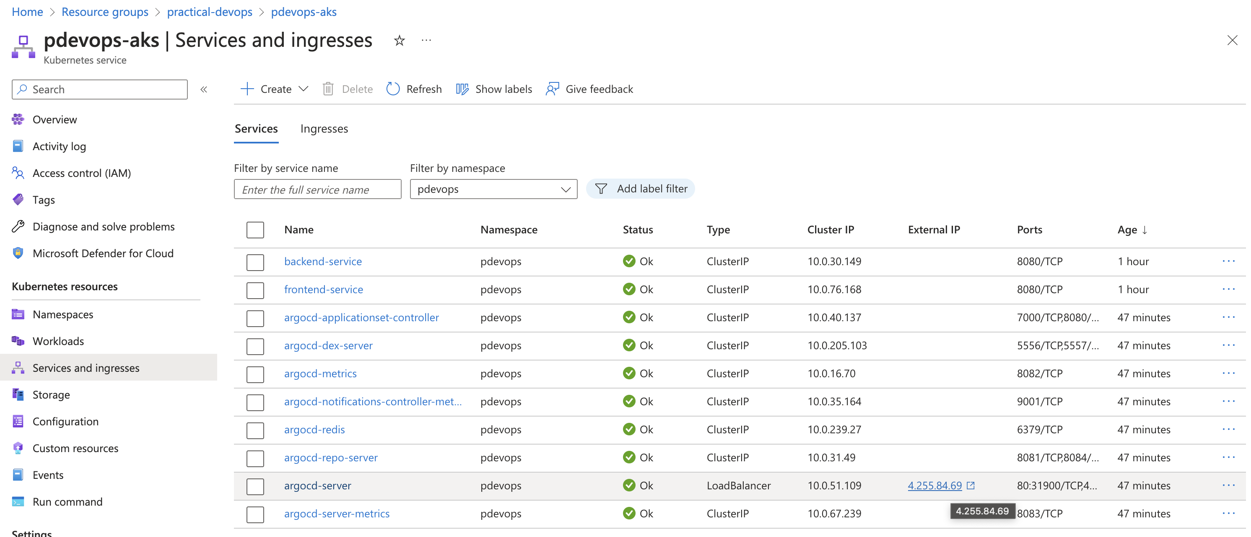

Log in with Userame “admin” and Password:

export ARGOCD_PASSWORD=`kubectl -n argocd get secret argocd-initial-admin-secret -o jsonpath="{.data.password}" | base64 -d`

echo "ARGOCD_SERVER PASSWORD: $ARGOCD_PASSWORD"

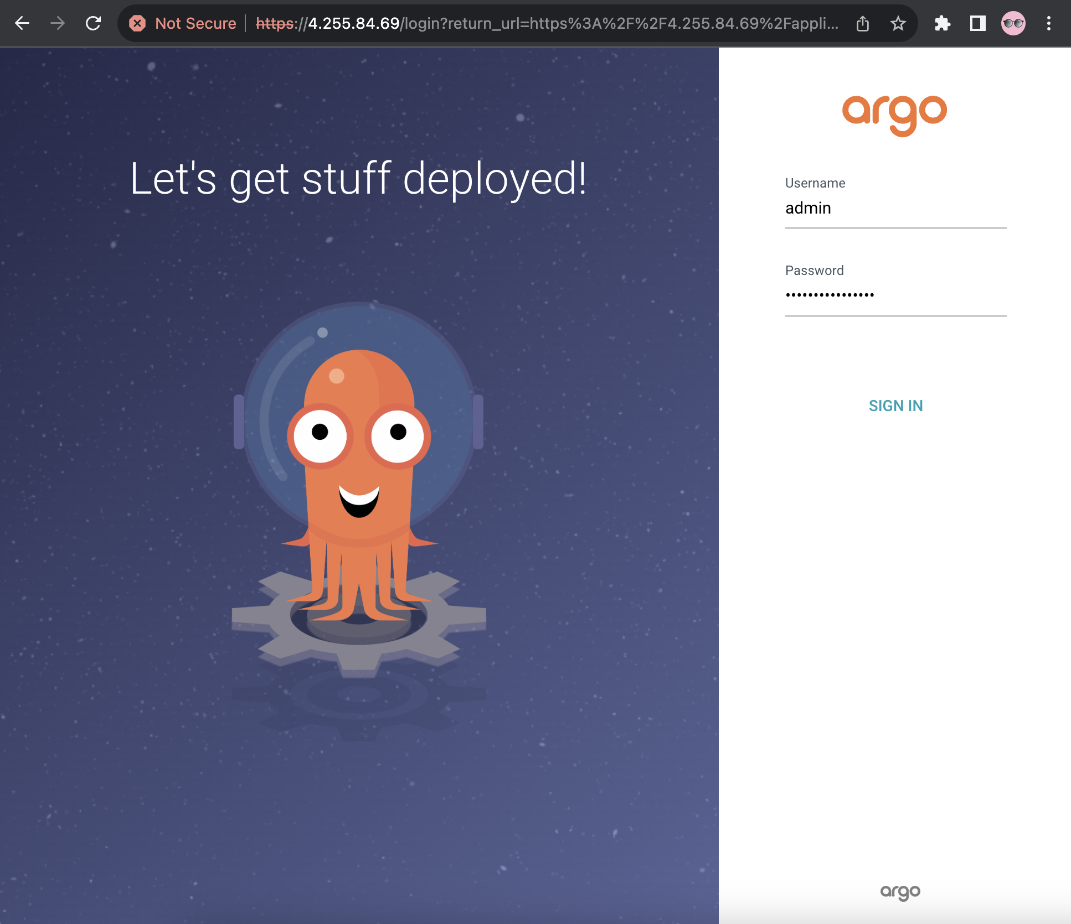

## Create applications on GUI

Add new project: Go to Settings 🡪 Project 🡪 NEW PROJECT

* Project Name: practicals-devops
* Source repositories: *
* Destinations: */*/*
* Cluster resource allow list: */*

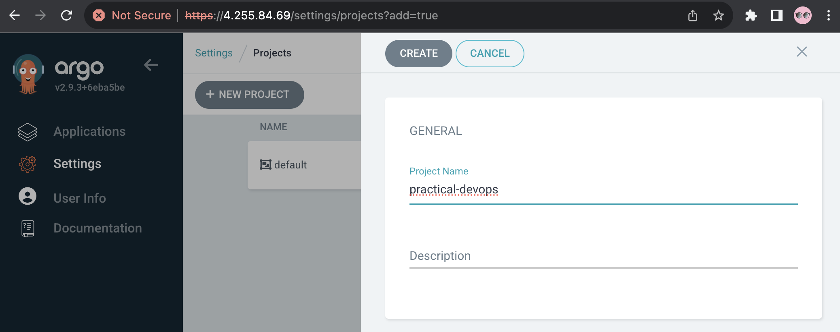

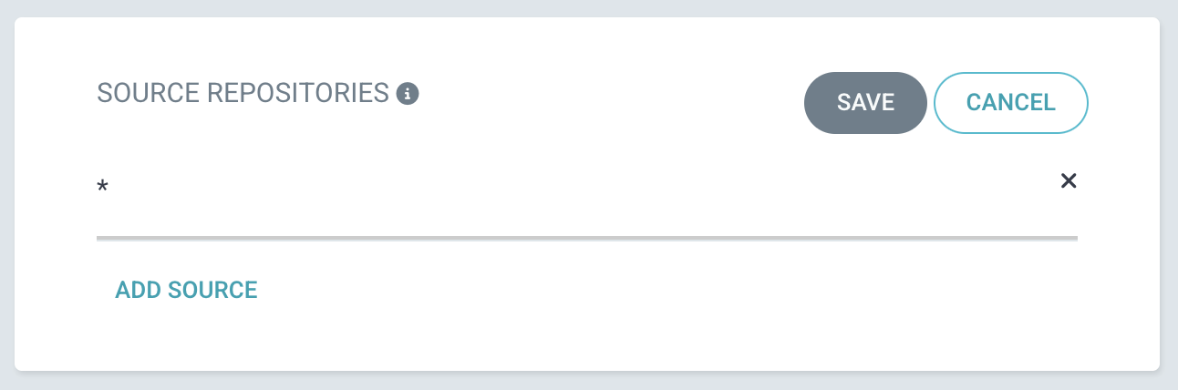

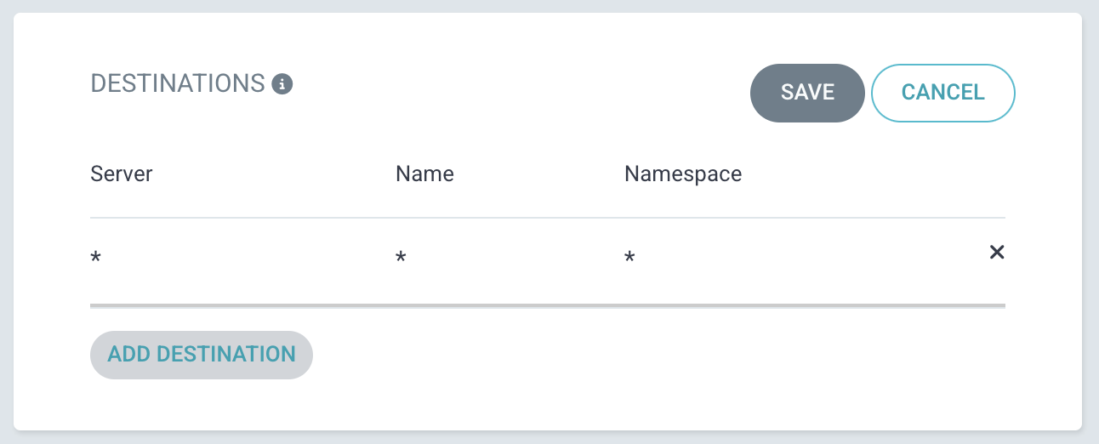

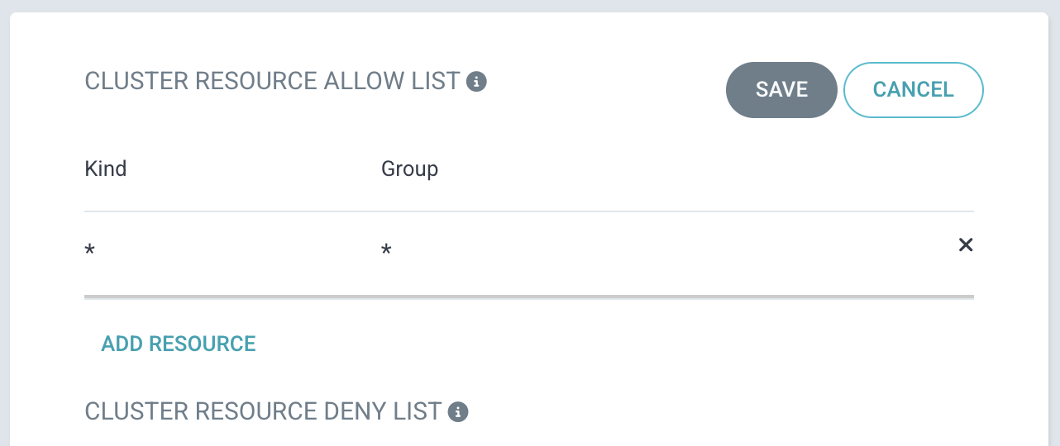

Connect new repository: Go to Settings 🡪 Repositories 🡪 CONNECT REPO

* Project: practical-devops
* Repository URL: <https://github.com/nhiphannty/devops-ci-cd>

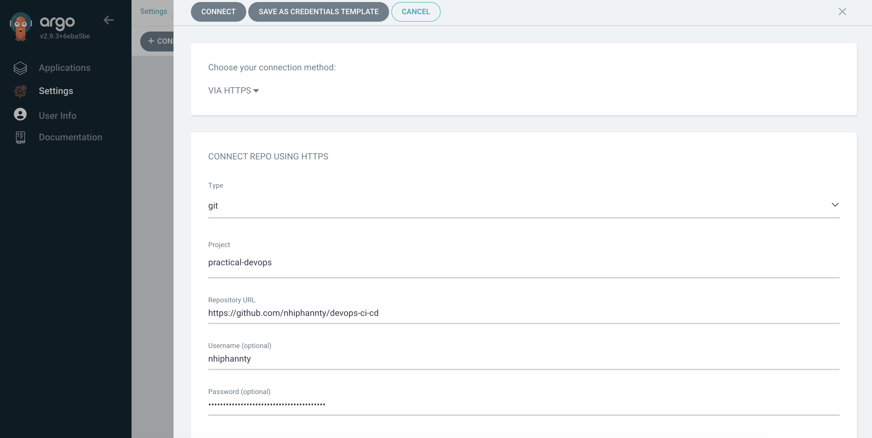

Add application: Go to Applications 🡪 NEW APP

* Application Name: backend
* Project Name: practical-devops
* Repository URL: https://github.com/nhiphannty/devops-ci-cd
* Path: resources/deploy/aks/backend

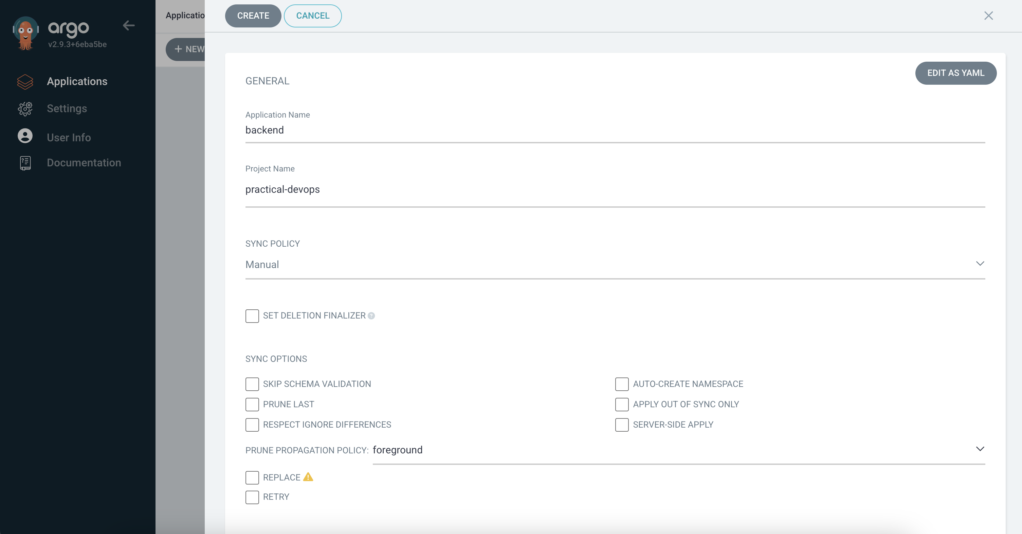

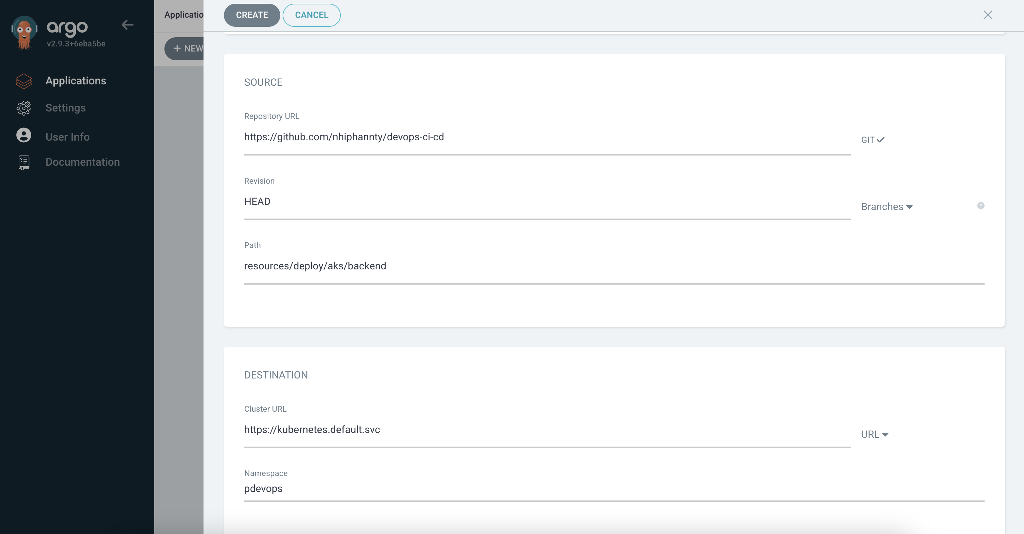

Choose SYNC for both applications

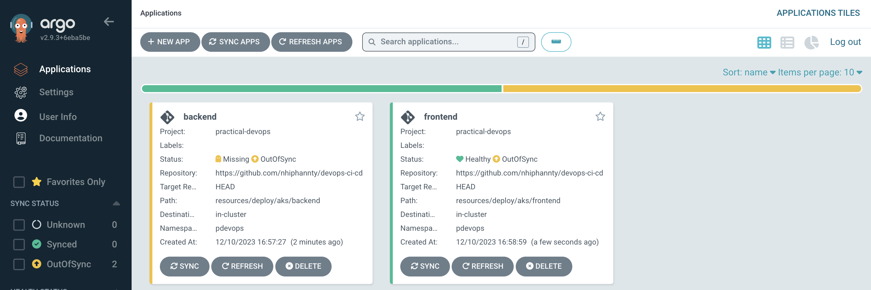

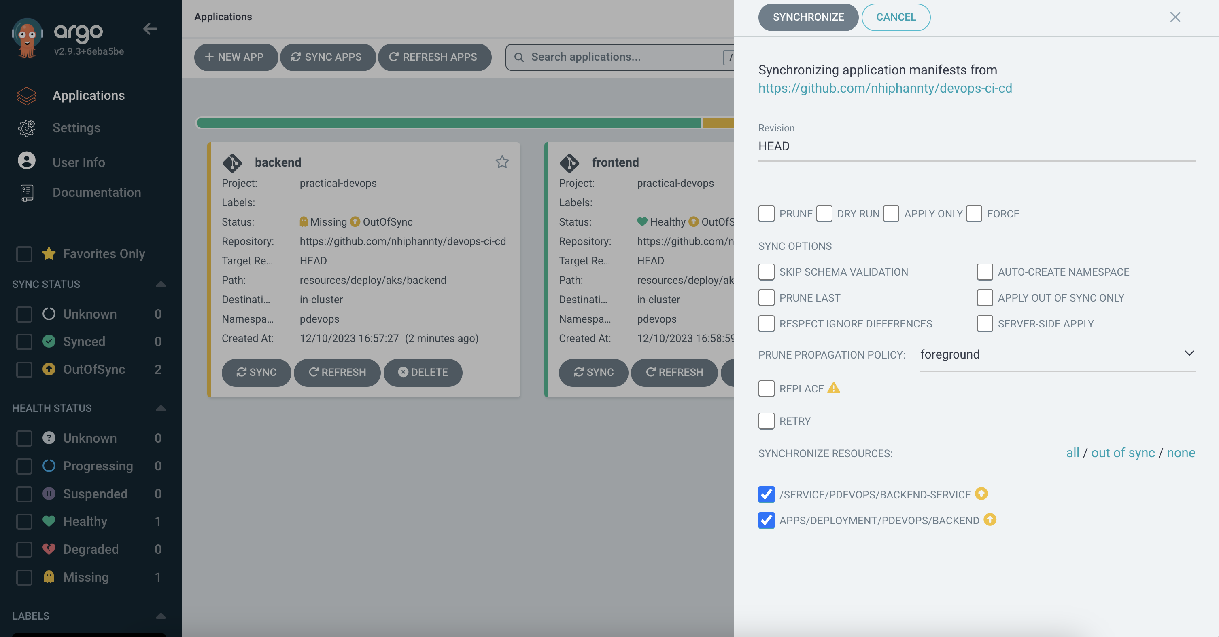

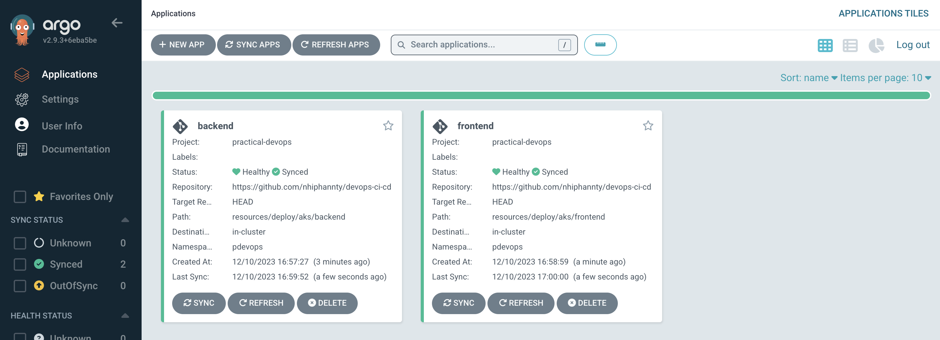

## Install Argo CD Image Updater

kubectl apply -n argocd -f https://raw.githubusercontent.com/argoproj-labs/argocd-image-updater/stable/manifests/install.yaml

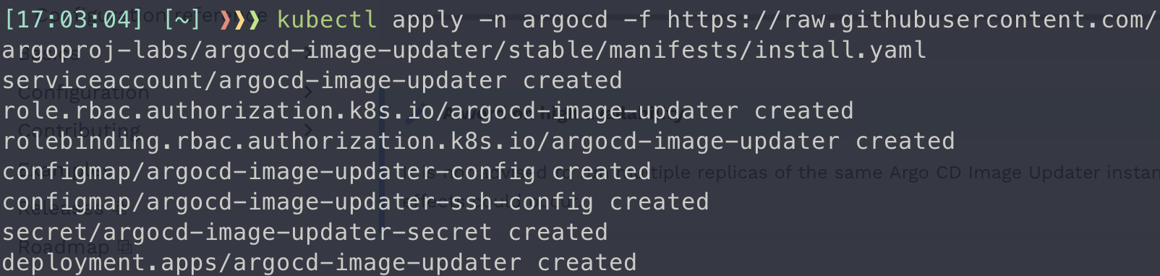

Create new account for API key capability

kubectl edit configmaps argocd-cm -n argocd

Add these lines:

data:

accounts.image-updater: apiKey

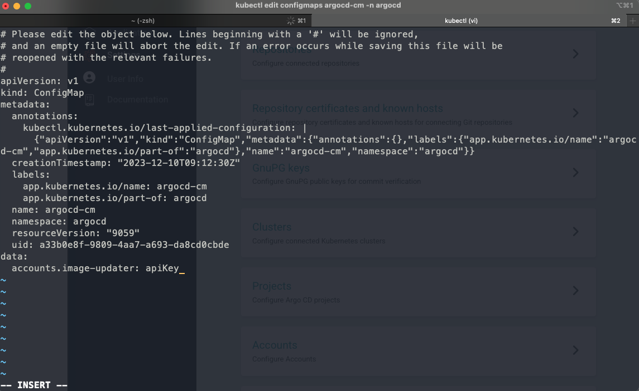

To save file, press Esc then type :wq and press Enter



A new account image-updater is created:

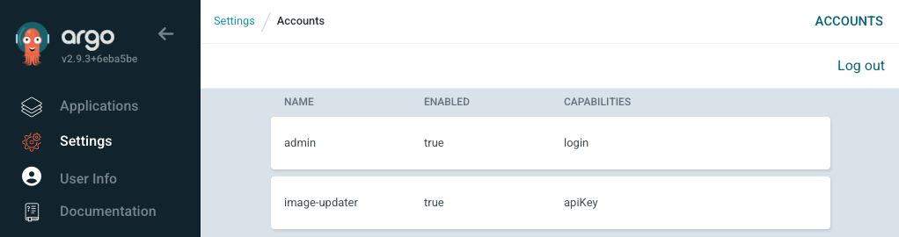

Generate token, save this token for step run

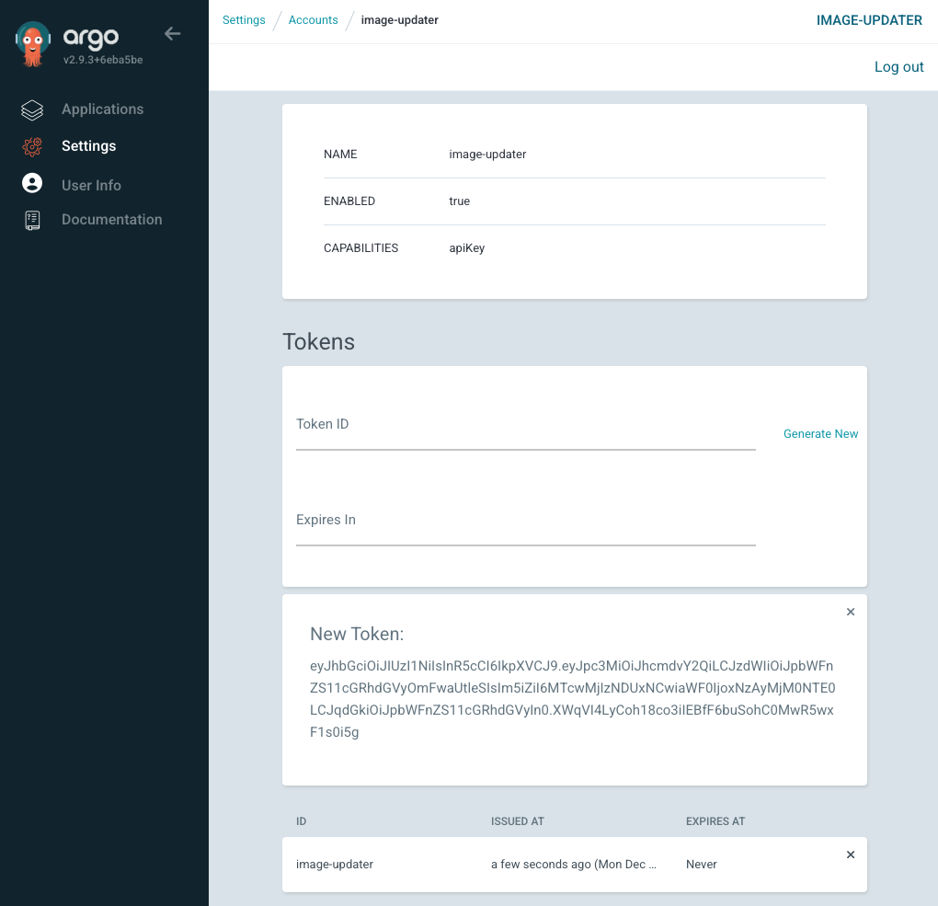

kubectl edit configmaps argocd-rbac-cm -n argocd

Add these lines:

data:

policy.csv: |

# assign permissions to role:image-updater

p, role:image-updater, applications, get, */*, allow

p, role:image-updater, applications, update, */*, allow

# grant account image-updater the role "image-updater"

g, image-updater, role:image-updater

policy.default: ""

scopes: '[groups]'

kind: ConfigMap

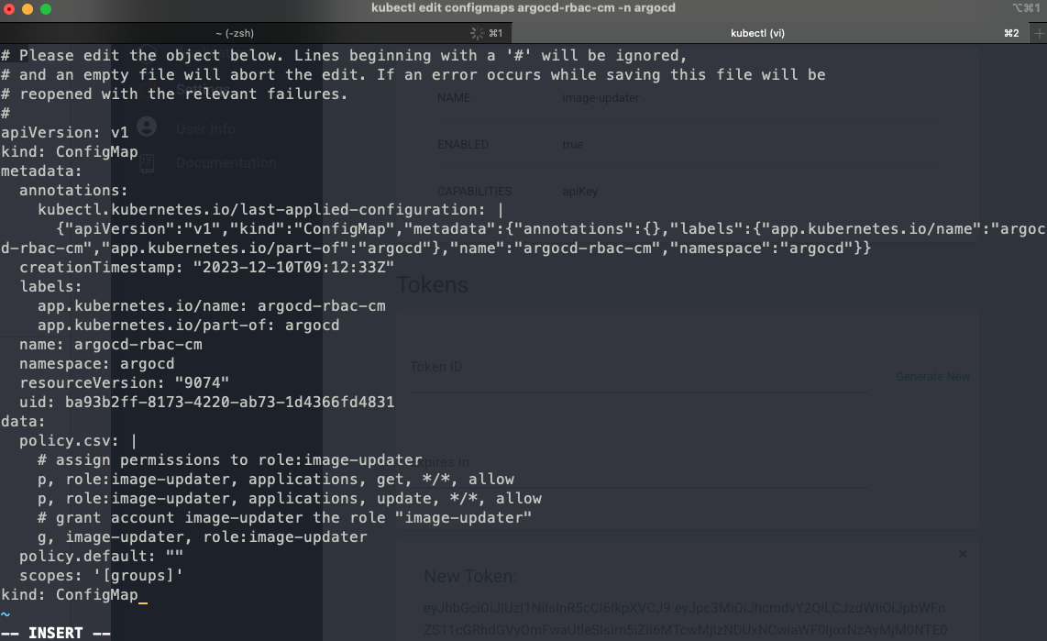



To apply new configurations:

kubectl -n argocd rollout restart deployment argocd-image-updater

Run:

export ARGOCD_TOKEN=${ARGOCD_TOKEN}

./argocd-image-updater run –once